Seed |  |  | School: |  | Lane #
 |  |  | Student-Athletes:
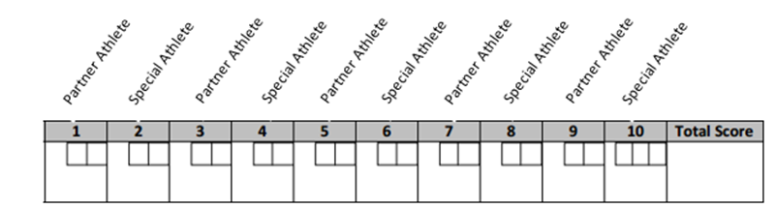
 |  |  | Coach Signature:

Seed |  |  | School: |  | Lane #
 |  |  | Student-Athletes:
 |  |  | Coach Signature:

